# EMPLOYEE APPRECIATION BASED ON CUSTOMER SATISFACTION

**Team members:**

Allam Yamini Divya

Gumma Anusha

Kola Manikanta

Meriga Sricharan

**Introduction:**

This project is useful for the companies to identify the employees who are giving their best in order to satisfy customer needs. Employee who are working efficiently will be appreciated based on their performance.If the customer is satisfied with the employee then he will be appreciated based on his performance.

Code screenshots:

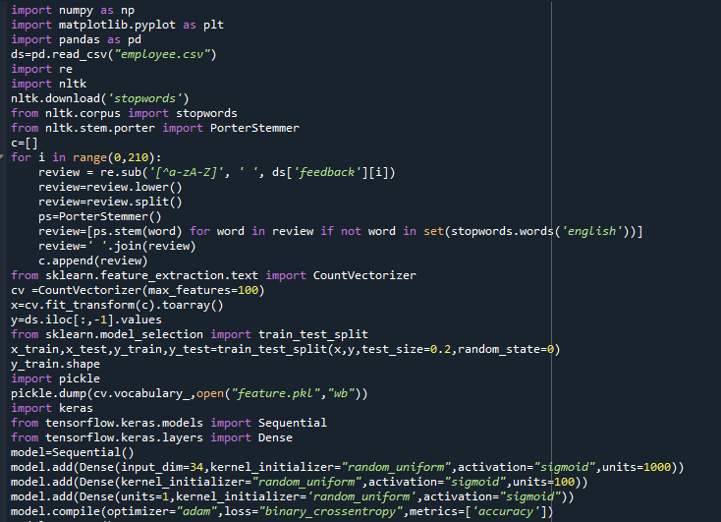

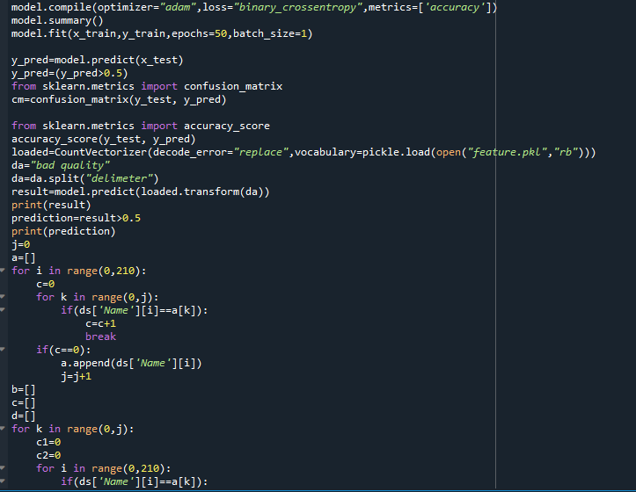

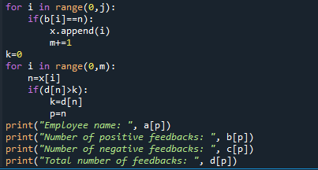

**Output screenshots:**

